RC tutorial 100 – Signaling interlocking train routes, 3D and Table example

=============================================================

Revised 2019-10-06

* This tutorial's goal is to show how to produce interlocking tables, 3D and Signal tables.
* Assumed RailCOMPLETE skills: Previous lessons, including 3D and basic Lua programming
* Assumed railway skills: You know about interlockings and railway signalling.
* Time to spend here: Intermediate: 30 min to 1 hour. Beginner: 1-2 hours.
* Notice to users with non-English versions of AutoCAD – see footnote[1].
* This example was prepared using software release 2018.22.1284 with Norwegian DNA version “2019.1 gamma”,”NO-BN;NO-0001;2019-09-28T20:19:00+01:00;2019.1”.
* Note: If you are using AutoCAD version 2017 or older, then open the 2013-format version of the tutorial DWG file.

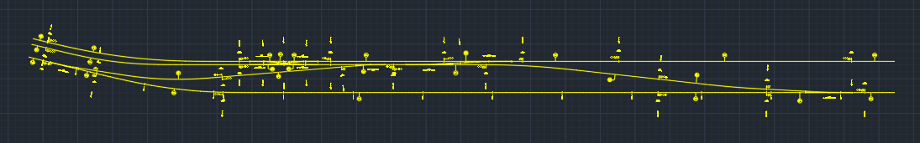

1. Start AutoCAD with RailCOMPLETE, then open the ‘General Tutorials’ folder and locate the DWG file named after this tutorial. You can either type RC-ShowGeneralTutorials or you can locate the button below the RC logo in the upper left corner of your AutoCAD window.
2. First build your track network, imported from LandXML or other. We have prepared an example using one of the standard tutorials LandXML files, “Example station XYZZY” in the General Tutorials folder in your Railcomplete bundle. Locate the LandXML example files by selecting Railcomplete/General Tutorials from the ribbon or run RC-ShowGeneralTutorials (it opens the Windows file browser at the default general tutorials’ location). Import that file using RC-ImportAlignmentsFromLandXml.
3. Assign reference track definitions to each track (see other tutorials), using the Alignment Manager.
4. Use RC-AssistCreateTrackConnectionObjects to auto-insert all switches and crossings. Clean up manually by changing the Variant to the correct 1:9, 1:12 etc type, if it didn’t come out right in the first place.
5. Assign numbers to all switches’ ‘code’ property (use the RC-ManageProperties tool and just write numbers in the code property for each of them in turn)
6. Insert all isolation joints, RcType == «KO-SKJ Isolert skjøt»
7. Then insert the “SA-SPF Sporfelt” to give names / numbers to each track circuit section. Use the RC-ShowSections tool from the Ribbon to turn on the “Section” highlighting. Each time you select one or more section numbers, the associated section / sections will be colored.
8. Use the Object Manager to assign a sequence of numbers to the track circuit sections (I usually auto-number the sections using their ‘Seq’ (Sequence number) property and the Object Manager’s AutoFill Series function, and afterwards assign for instance the formula “800+Seq” to each section’s ‘code’ property)
9. Then insert your “Class B” signals (i.e. optical signals, not the ERTMS system).  You must use the Norwegian signal types - “Hovedsignal” is a main signal, and “Dvergsignal” is a dwarf signal (shunting signal). Main signals may have shunting signals on the same mast. “Forsignal” is a distant signal.
10. Assign numbers / letters of the form ‘12345L’ or ‘X432’ or ‘C’ or ‘246’ to main signals, so you can recognize their names in the interlocking control table you will make (use the ‘code’ property). Shunting signals usually have just a number.
11. Then use the RC-AssistCreateInterlockingTable function. It should work right away, but you can twist and tweak it to make it work better for your purpose.
12. Remember to refresh objects if they need to read other objects which have meanwhile been changed.
13. See the DWG and Excel example that we prepared for you.
14. The train route tables should like this (see XLS file):

1. To see the results in 3D, you can use start RC-Export3d. Activate the ‘Alignment’ tab. Uncheck the “Model Insertion Axis” and “Alignment Axis” checkmarks, because any of these two choices will suppress expressing the alignments (your tracks) using their associated 3D object models. Make sure that the 3D Model Name property has been set to one of the standard sleeper-and-rail models that you can find in the bundled 3D\STD library for 3D object models, for instance NO-BN-3D-KO-SVI-SLEEPER-AND-RAILS. To check this, select your tracks and inspect the RC-ManageProperties tab ‘3D’. In RC-Export3D tab ‘Destination’ , you can select between sending the generated 3D to an external file or to a layer in your drawing.
2. Once everything is set up concerning 3D export, you can turn on 3D preview  and just select objects – they “pop up” in 3D once they are selected. To “freeze” them as ‘dead’ graphical entities in your drawing, right-click and select ‘RailCOMPLETE Annotation => Copy Annotations to Drawing”.
3. This is what your model should look like in 3D:

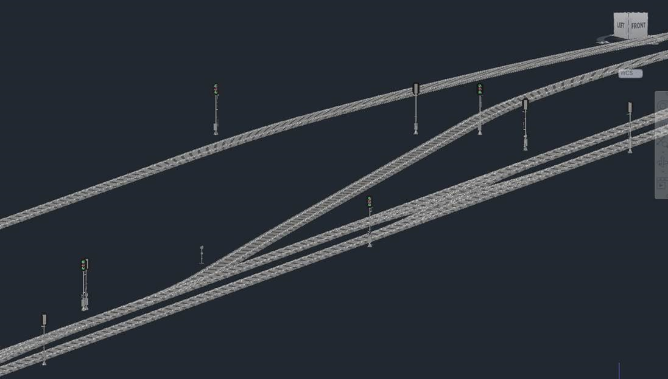

1. From here on, you may experiment yourself putting in boards, ID-boards that you attach to signals etc.
2. Try to produce a table using the “Create Table” button in the ribbon, or the RC-CreatePredfinedTable command. Below you will find an example of a standardized table type “FE-DIV Signaltabell” and Variant “Signaltabell Enkel”. Make sure to enclose text containing spaces in double hyphens (“*text with spaces*”) if you are using the keyboard version of the command instead of the ribbon button for Create Table, otherwise AutoCAD will just use the first word entered.

1. Have fun!

Please check our website www.railcomplete.com for updates.

Corrections and suggestions are welcome to support@railcomplete.no.

Thank you for using RC Tutorials!

1. Your AutoCAD session has probably been started from a Windows shortcut of the type:  
   “C:\Program Files\Autodesk\AutoCAD 2019\acad.exe” /product ACAD /language “fr-FR”  
   (“fr-FR” means “French language, France’s version) similar. Native AutoCAD commands may have different names in your language pack, other than the COPY, COPYBASE, FIND etc that you see in our tutorial texts. In order to instruct AutoCAD to accept the native English command name, precede the native (English) command name by an underscore character, ‘_’. For instance: ‘_FIND’ will start AutoCAD’s native ‘FIND’ command even if you are using AutoCAD with the French language pack, where the command in French is called ‘RECHERCHER’.If a command needs an argument ‘ON’, and the French menu says ‘Allumer’, then you can enter ‘_ON’ to instruct AutoCAD to use the option’s native name.